**ITI 200 Introduction to Cloud Computing**

**[WindowDash]**

**Team Members**

Brendan Taylor

Lucas McColgan

# 1. Problem

Doordash involves the usage of a driver, these drivers may not always be available, and are rather expensive as a car isn’t the most gas efficient vehicle to transfer packages. They may also not properly complete the delivery.

# 2. Solution

In our solution, we decided that replacing the driver and cars with automated drones would solve all of these issues. Drones are always available to be ordered from, are cheaper to operate for the customer, and don’t need to take the roads

# 3. Presentation Video

<https://youtu.be/RyM9mQyHQ3I>

# 4. Lessons Learned

* We learned that making a “website” map is a good idea for layout planning.
* Assign a scope to the project to make sure it doesn't go outside of that scope (ie too many webpages).
* Cookies have hard syntax.
* Linking EC2 servers and Databases are not to be underestimated

# 5. Issues/Bugs Known

* If the user enters a name already in the database, the button turns red and won’t change back.
* When the server restarts, it forgets user id’s and sets them all to 0’s.
* The system will let the user continue if they press the button twice. 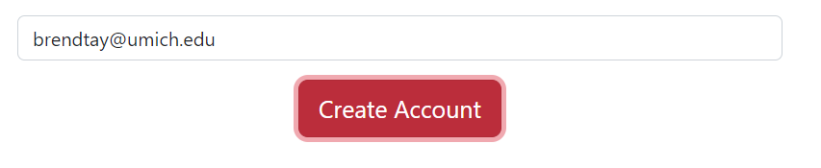
* The server crashes when trying to query the database only when connected to the aws server

# 6. Future Versions

* Multiple Deliveries at a time
* An algorithm that determines price by distance
* Suggestions based per user
* A ordering system that is based per user
* Make it more visually appealing

# 7. References

<https://www.w3schools.com/js/js_cookies.asp>

<https://stackoverflow.com/questions/40141332/node-js-mysql-error-handling>

<https://www.restapitutorial.com/httpstatuscodes.html>

<https://www.w3schools.com/nodejs/nodejs_mysql_insert.asp>